**Chapter 02: Literature Review**

**2.1 Overview**

While working on this research project, we have studied various research papers based on our project topic and selected few papers from there which were conducted on IoT based Home Automation system and Zero Crossing detection technique. We chose these selective papers because their working approach is closely related to our research work and gathered some ideas from there for doing our work.

**2.2 Existing literature explanation**

Although Home Automation systems are not that common in our country, considerable amount of research and implementations has been done by various authors in various countries.

* Ravi Kishore Kodali et.al [ ] proposed an IoT Based Smart Security and Home Automation System. Where the electrical appliances generally work through only Bluetooth enabled smart phones, which in some contexts cannot be managed from a distant location. In order to modify the existing home automation solutions, the writers proposed a system which can be served as a smart security system and as a smart home automation system as well. The main objective of this IOT based project focuses on building a smart wireless home security system which sends alerts to the owner by using internet in case of any trespass and raises an alarm optionally. And also, the system can be used as home automation by making use of same sensors.
* Kumar Mandula et.al [ ] proposed a system where the goal was to apply a solution towards smart governance, smart education, smart agriculture, smart health care, smart homes etc. But this paper explains how this device can be used for smart home automation using microcontrollers (Arduino) along with an Android mobile app. The device will be controlled through Bluetooth in an indoor environment and Ethernet for outdoor environment.
* R. Baris Dai et al [ ] proposed dimmer circuit for controlling three different light sources incandescent bulb, CFL and LED. Different kind of light sources are studied and tested with AC and DC sources. Experiments were performed in order to observe the electrical characteristic of the dimmer and optical characteristic of the lighting devices when they are used with the dimmer circuit. The experimental results showed that the proposed dimmer can be used with these kinds of lighting devices within specific output voltage ranges.
* Jong-Hyun Kim et al [ ] proposed a simple dimmer using a MOSFET for AC driven lamp such as AC LED and incandescent lamp. The control method of the proposed dimmer is pulse width modulation (PWM) method. Compared with the conventional phase-controlled dimmer, the proposed PWM dimmer can produce sine wave and it does not cause harmonics problem.

One of the research papers that we read, explained about the energy monitoring module, where various research was done to efficiently measure the voltage, current and power in different forms [ ]. The explanation below shows how energy units can be measured.

The concept energy saving and consumption monitoring embedded into our daily lives is becoming more and more popular and essential as the global population is rising and resources are becoming more and more limited. The importance of these applications has, cannot be ignored.

The key element for accurate power consumption data to record and analyse energy usage is the power meter. The power meter requires a voltage and current sensor to measure parameters like real or true power, apparent power and power factor etc. Only one of each sensors is needed to measure power in a single phase source. In this case a voltage and a current transformer were used. The output voltage and current are determined by the number of turns on the primary and secondary side. An Arduino mega was used to process the signals and make necessary calculations by taking the signals through its built in Analog to Digital converters.

In another paper, the research was conducted to implement various methods for detecting zero crossing [ ] which helped us to gather knowledge about their different approaches for zero-crossing detection. These methods have been discussed below -

Zero crossing is a term commonly used in electronics, mathematics, image processing and sound. It is the point in a sinusoidal wave, where the mathematical function transits from a positive cycle to a negative cycle, or vice versa. Zero-Crossing detector is a device that is used mainly for measuring the frequency, period, or phase difference of a periodic AC signal by detecting the time period between two or more zero crossing points.

There are many methods to detect zero crossing proposed by various authors. Some of them are:

* **Zero crossing detection by interpolation –** This uses two signals from a single source where one point is found just before the 0V of the main signal and the other point is found right after the 0V of the same signal. These two signals are then interpolated to converge towards a new point that is close to the 0V point. This method required computer processing.

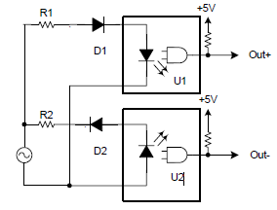

**Figure 2.2.1:** Circuit for dual point interpolation method for detecting a zero crossing.

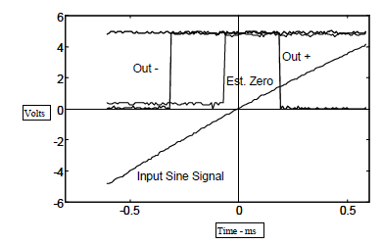

**Figure 2.2.2:** Oscilloscope capture of the sine wave signal, optoisolator outputs and computed zero crossing.

* **Comparator circuits with fixed hysteresis –** This circuit takes the input of the main signal and compares the voltage with two reference voltages. One that is at zero and another that is close to zero. This prevents multiple zero crossing detection that occurs near the zero crossing point of the sinusoid.

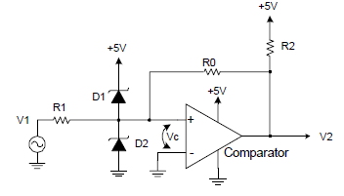

**Figure 2.2.3:** Resistive feedback hysteresis circuit.

* **Comparator circuits with dynamic hysteresis. –** This circuit works just like the fixed hysteresis circuit but has dynamic threshold voltages that further prevent multiple zero crossings. A capacitor is added at the feedback that adds to the positive feedback when the first zero crossing is detected. And then the feedback slowly decays overtime to dynamically change the threshold voltage.

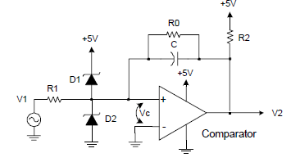

**Figure 2.2.4:** Dynamic hysteresis comparator circuit.

This information was needed so that when a zero crossing is detected, the pulse signal can be delayed at will, using a microcontroller to the input of a TRIAC gate. This will cause the TRIAC to switch on at a different phase of the AC source, hence giving the user the ability to control the output power towards the load.

The power electronics have proceeded quickly since 1960. Between 1960-1970 thyristors and triacs came to market. Using those components it was quite easy to make small and inexpensive light dimmers which have good efficiency. Electronics controlling also made possible to make them easily controllable from remote location. This type of electronic light dimmers became available after 1970 and are nowadays used in very many locations like homes, restaurants, conference rooms and in stage lighting.

After 1960 power electronics have proceeded very quickly. Tyristors and triacs came to the market and became readily available during that time until this day. The dimmers were small and inexpensive and had a very good efficiency compared to previous methods. This also made it easier to control from remote locations.

**2.3 Status of Home Automation in terms of global and our country aspect**

Technology is evolving decade by decade. In today’s era, technology can enhance human life by combining latest technology with home and can bring comfort and convenience to people’s regular lives. Today with the help of technology and internet, people can build a home automation system which can operate commonly used home devices automatically and can provide convenient life to people.

Earlier automating electrical devices were totally mechanical. For example; lighting system, air-conditioning system, television remote control, switching fan etc. But today, with the invention of computer system, researchers have created computer based intelligent systems such as, touch-screen controlled home automation systems that come up with much functionality. This touch screen controlled system has a graphical user interface such as, buttons, icons, images etc and by touching on these buttons or icons, users can give commands and automate the control of electrical devices at home. Using this computer based home automation system or touch-screen controlled home automation system, users can operate their regularly used home appliances such as, lights, fan, AC, TV etc remotely which can reduce people’s hard labour in performing these day-to-day activities and can accelerate the working speed of users.

Nowadays, as technology is advancing at rapid pace, new technologies are being introduced into homes worldwide. The high-tech gadgets are making homes smarter today. There has recently been observed a significant rise in the number of smart home connected devices compared to the earlier times. In 2015, there were 111.5 million connected households worldwide, with North America having the highest rate of 23 percent. Europe is the second fastest growing region in terms of the number of smart homes. Asia-Pacific is still in the beginning stage in terms of experiencing smart homes, but the market is expected to grow quickly after 2018.

In recent times, the Zigbee home automation market is getting popular internationally. Zigbee is a wireless technology (it’s widely considered an alternative to WI-FI and Bluetooth) which aims to provide the foundation for IoT with features to support low-cost, highly reliable networks for device-to-device communication. Zigbee-enabled devices in home automation allow the devices to work and operate together while also giving users the ability to control them. Report says, the global Zigbee home automation market is likely to increase at an annual rate of 26 percent from 2016 to 2020.

With the development and rapid growth of technologies, the people in Bangladesh are gradually being introduced to the latest technologies, such as; smart phones, computers etc. But the current scenario in Bangladesh in terms of smart homes use, is not very notable. Here, many people in our country are still not technologically literate, they are not very familiar with computers and cannot directly interact with computers. This is why they are not aware of the flexibility and convenience that a home automation system can bring into their lives. Moreover, establishing a home automation system seems very costly to many people in here. However, effective initiatives are being taken to remedy this situation here. ICT-based education is being implemented in the primary to tertiary level in Bangladesh, cost of technologies and internet usage is gradually decreasing and quick expansion of wireless internet service is being seen nationwide. The Ezzy Automations Ltd. is the first Home Automation solution provider in Bangladesh enabling people to establish and utilize the home automation system at their homes. They are providing a home automation service to people which allows users to access their home systems remotely from anywhere and also their automation service enables the automatic control of commonly used home appliances such as, lighting, temperature, security and other home devices. Ezzy group in Bangladesh has developed a nationwide network and their automation solution includes lighting automation, home automation, security automation etc. Through their home automation service, they are bringing comfort in people’s home life, reducing human effort and transforming the definition of way of their living. Gradually, the market of Ezzy automation group will be expanding nationwide in the coming years.

**2.4 Summary**

In this chapter, we have explained about other researchers’ working method on the topic of ‘Home Automation system’ and ‘Zero Crossing detection’ whose approach is quite similar to our project work and discussed how their working strategy helped us gain some ideas to solve some problems in our project. Here, we have also discussed about how Home Automation is becoming popular everywhere, provided some statistics on the implementation of Home Automation system worldwide and explained the reasons why it is not being extensively used in our country. We also mentioned a company named ‘Ezzy Automations Ltd.’ which made the people in Bangladesh introduce to the Home Automation system for the first time.